|  |  |  |  |
| --- | --- | --- | --- |
|  | Bansilal Ramnath Agarwal Charitable Trust's  Vishwakarma Institute of Information Technology  **Department of**  **Artificial Intelligence and Data Science** | | |
| Name: Siddhesh Dilip Khairnar | | | |
| Class: SY | Division: B | | Roll No: 272028 |
| Semester: IV | | Academic Year: 2022-2023 | |
| Subject Name & Code: Software Engineering, ADUA22204 | | | |
| Title of Assignment: Write down Customer Problem Statement (CPS). | | | |

Aim: Write down Customer Problem Statement (CPS).

Background Information:

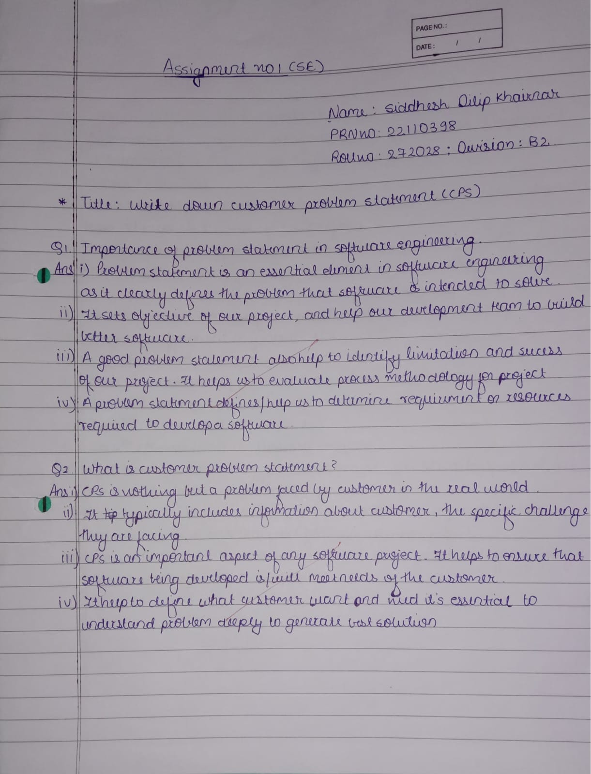

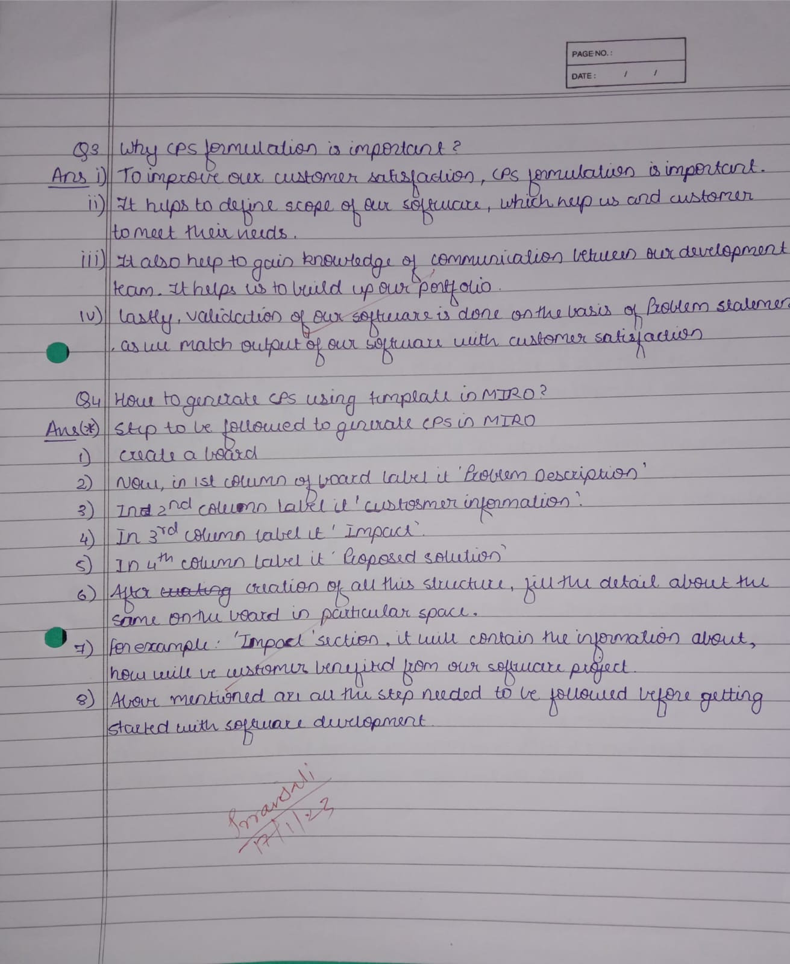

Software Requirements: Miro Formulation of Problem Statement:

CPS I: A student want to learn web development from a platform.

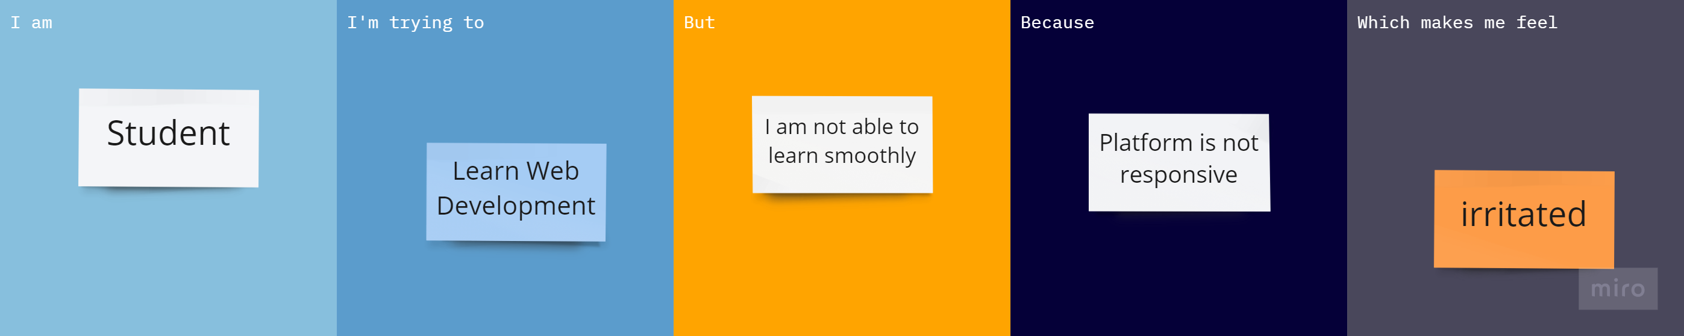

CPS II: A scientist wants to read research on article but unable to complete it due to some financial constraints.

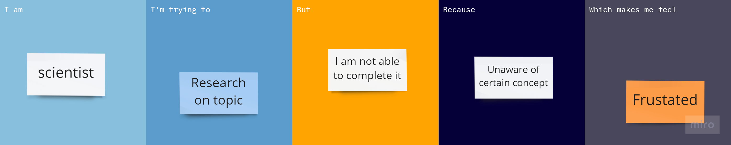

CPS III: Entrepreneur want to invest in stock but unable to complete deal.

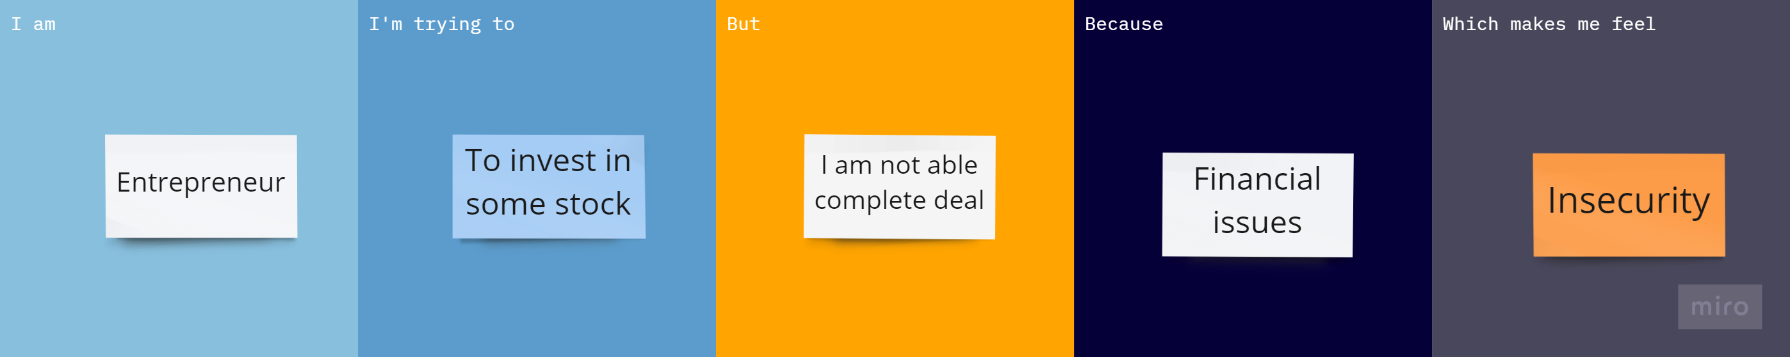

Conclusion: We have successfully generated CPS using templates in Miro.